Falaise Pocket
41
MILITARY
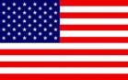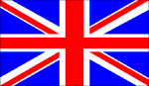
1ST US 3rd US 2ND BRIT 1ST CAN
AIR POWER
Jabos: +1 2nd BRIT; +1 1st CAN
RESOURCES
NONE

ORDERS: 1 Action
+1 Attack Strength 1st CAN
+1 Defense Strength 2nd BRIT

The battle of the Falaise Pocket, fought from 12–21 August 1944, was the decisive engagement of the Battle of Normandy. Taking its name from the area around the town of Falaise within which the German Seventh and Fifth Panzer Armies became encircled by the advancing Western Allies, the battle is also referred to as the Falaise Gap after the corridor which the Germans sought to maintain to allow their escape.] The battle resulted in the destruction of the bulk of Germany's forces west of the River Seine and opened the way to Paris and the German border.

